Breadboard Configuration (picture)

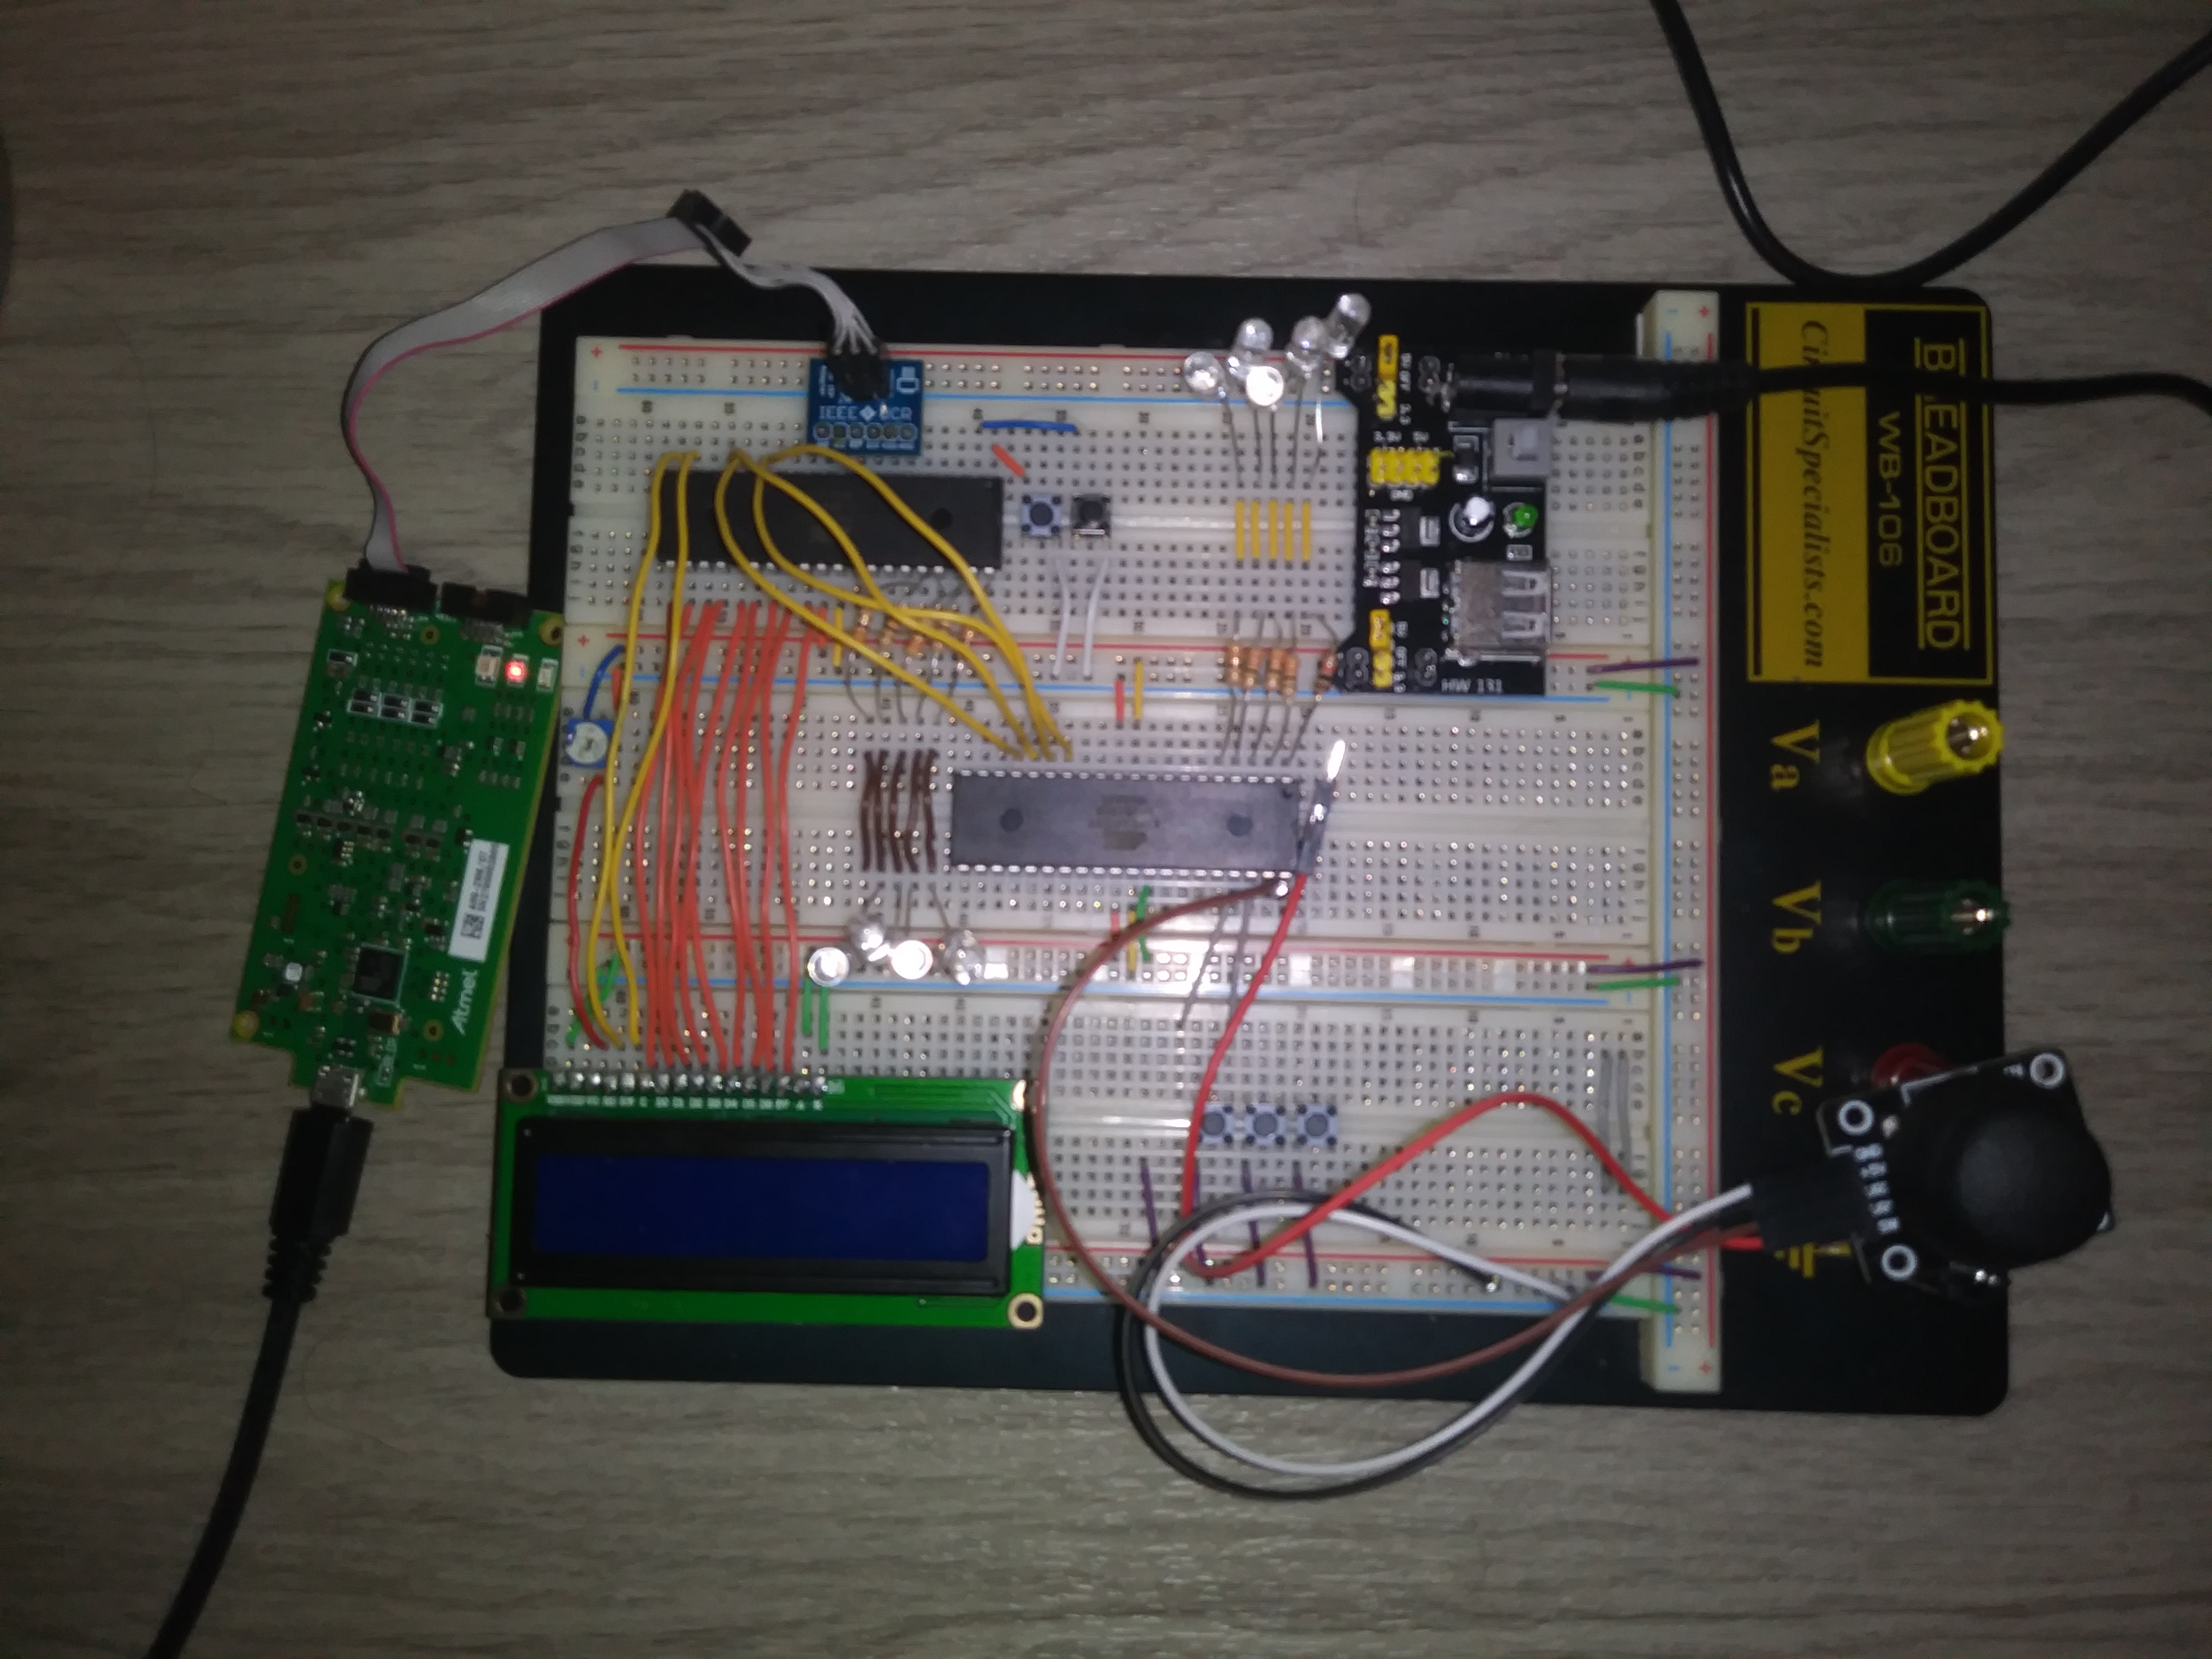

The joystick above is connected to GND, 5V, and PA0 on the bottom microcontroller.

The Start button is connected to PB0 on the top microcontroller.

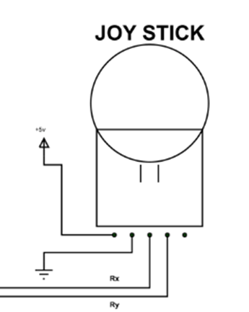

(Rx->PA0)

LCD Microcontroller Joystick Microcontroller

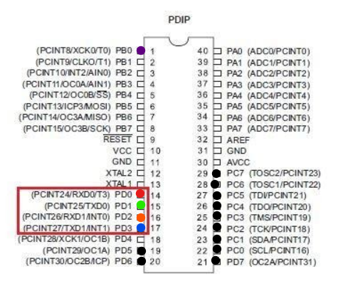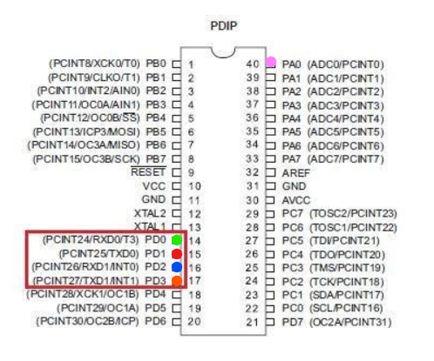

The red box shows how the usart pins are connected between the microcontrollers

The pink dot shows the pin where the Microcontroller connects to the joystick

The purple dot shows the pin where the Button is connected to the other Microcontroller

The Black dots are the pins that are connected to the lcd.

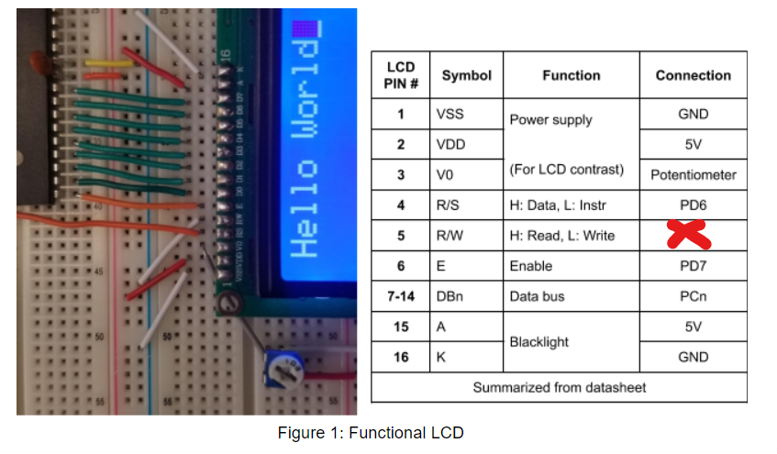

These are the connections for the LCD

**Note that R/W is connected to PD5 instead of GND**